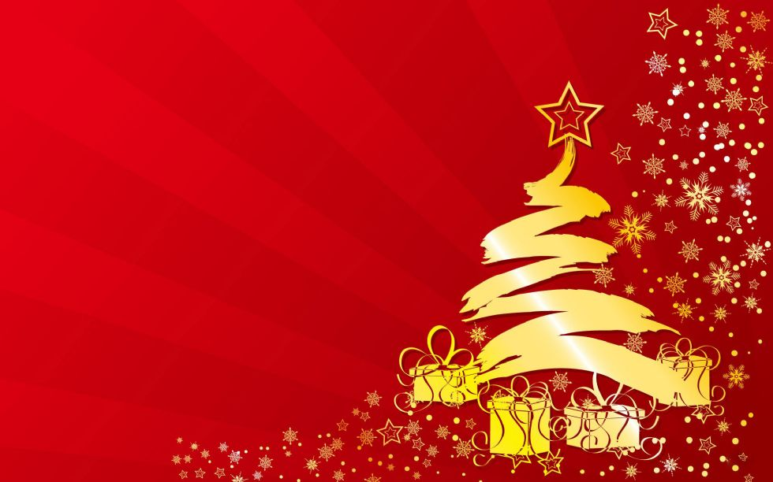
SUGAR SHACK BAND
CHRISTMAS CONCERT
thurSDAY DECEMBER 13th, 2018
LOWER LOUNGE
pizza & soft drinks will be served
Concert STARTING AT 4:30-5:30pm
get that lovely warm, happy feeling
with ChristMAS carols.

We look forward
to seeing you all!

