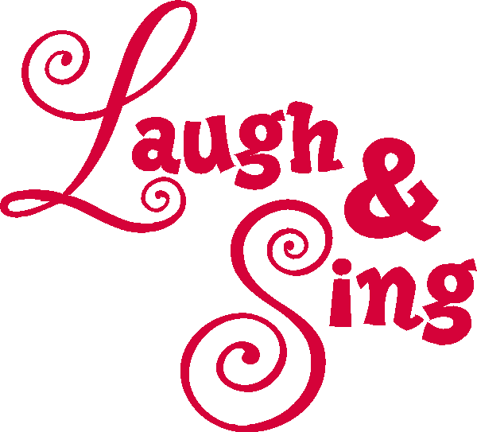

Got a talent you want to share?!
You can sing, dance, tell us a joke or just laugh
Come join the fun
Friday February 8, 2019 12 p.m.

